**The Boskowitz-Bloch Family History**

(prepared by Emily Buckman Good-May 2024)

NOTES: Because dates provided come from various sources, I have found some discrepancies, even when official documents were consulted. Corrections are welcomed. This file is presented mainly to share photographs of our ancestors and limited information on their children. Please refer to the extensive family trees for more complete lists of descendants. Since Sophie was my great grandmother, I have additional photographs and documents to share below.

**Minna Boskowitz** (August 13, 1838 – July 8, 1878) married on January 21 1863, **Abraham Hirsch Bloch**

(1826 – November 24, 1887). *Information from Allan Pinkus*: Abraham and Minna both came from the small town of Floss in eastern Bavaria near the Czech border. (Abraham was actually born in a smaller town some 10 km away as his father was one of the first Jews of Floss to buy an agricultural patch. It had been forbidden before that.)

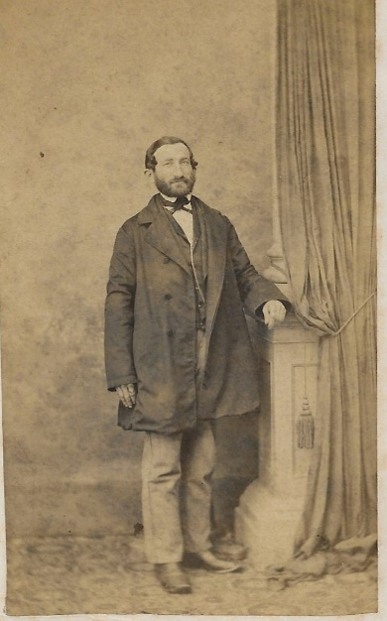 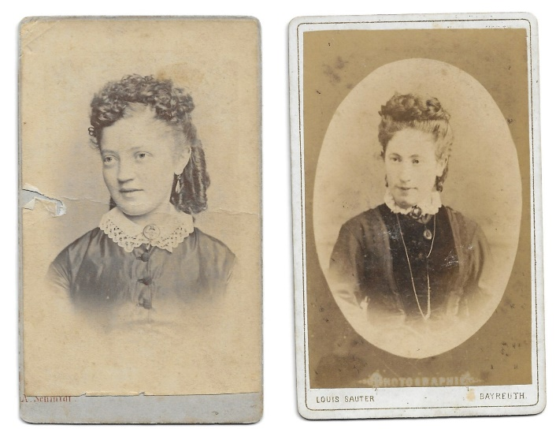

Abraham Bloch Minna Boskowitz

Abraham and Minna lived in Floss and at the time their daughter Sofie was born in 1872, this was their house.

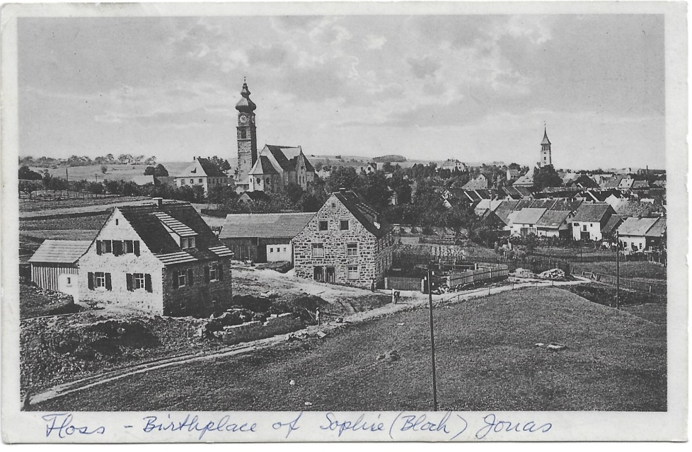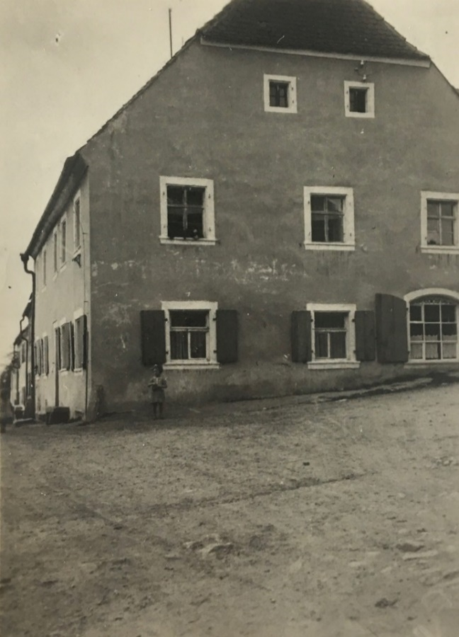

Minna gave birth to seven children. The youngest, Julius, died in his first year (April 11, 1874 - Feb 11, 1875). The other six siblings were: Henriette/Jette, Heinrich, Anton, Joseph, Arnold, and Sophie. Minna died in 1878. Abraham then married Carolina Weinschenk. Carolina, while single, had moved to Georgia in the US to be the housekeeper for her two bachelor brothers. When they married, Carolina returned to Germany and eventually married Abraham. Carolina became step-mother to the six siblings. Sophie’s daughter Minnie (my grandmother) remembers her step-grandmother playing American folk songs on the piano.

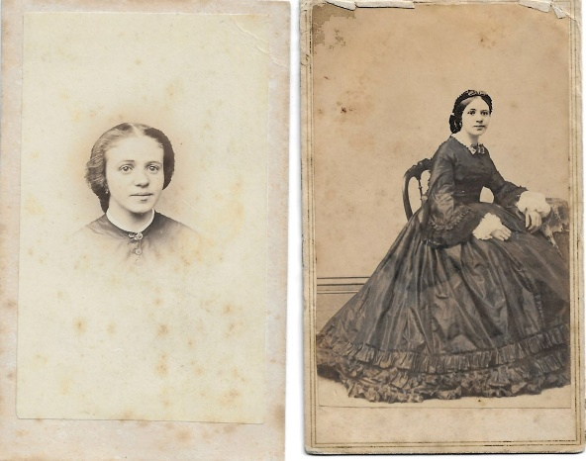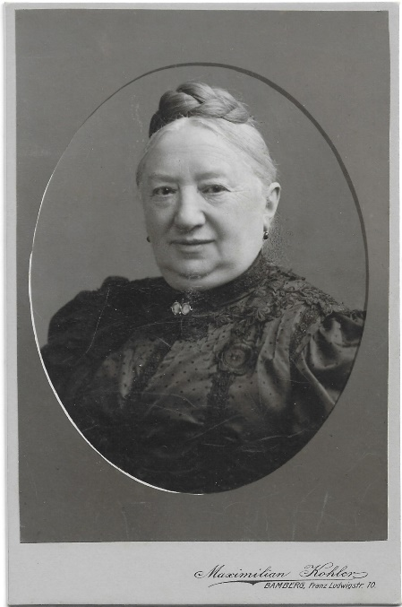

Carolina at different ages

**The Bloch Siblings**

**Henriette/Jette Bloch**

(July 6, 1864 – November 1, 1938)

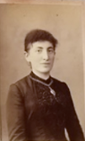 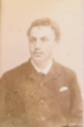

Henriette/Jette Solomon

On March 12, 1887, Henriette/Jette married Solomon Lipp (March 5, 1862 – December 20, 1924). They had three daughters: Wilhelmine/Mina, Mathilda/Tilda and Elsa. In 1936 Widow Jette moved in with Mina and Willi Engelbert. She died in 1938.

**Wilhelmine (Mina)** **Lipp** (March 26, 1888 – June 3, 1842 Holocaust) married **Willi Engelbert**

(Dec. 6, 1874 – March 16, 1942). They had two daughters:

**Elfriede (Friedl) Engelbert** (August 23, 1911 – August 1, 1986)

Married Alex Schwarz. Immigrated to Israel.

**Edit Engelbert** (June 6, 1916 - August 4, 2012 in Ashkelon) Immigrated to Israel.

Married Moshe Dorot (April 18, 1915 – d. 1982)

**Among my grandparents’ letters was this correspondence from Willi, who was desperately trying to find a way to safety. Only the daughters were able to achieve that end.**

*February 5, 1939*

*Willi Engelbert, Kassel*

*Hohenstorstr. 7*

*My Dear Ones,*

*We take courage to write to you about the extraordinarily bad situation in which we find ourselves. I will briefly describe the situation to you. I had to file for bankruptcy in August. Only the thought that I am not the one who has paid for a lot of business mistakes and only the thought that there are still thousands like me who were definitely as competent or incompetent as me kept me going. Until December I got daily support from the crowd and didn't need any people. Now our children have requested us and we hope, and the children definitely believe, to be there for the next certificate [visa] distribution. At the moment we live from the sale of individual pieces of furniture, and it cannot go on like this. Because we wanted to accumulate this income to cover freight (we should bring bedroom and kitchen) and travel expenses from this amount. And that works even when everything is sold, then we will have that amount. But if we continue to draw on it, one day when the certificate arrives, we will be left without means of travel and that would be bad. My friends tell me that I should cast off the false shame and turn to friends and relatives who are in a far better situation than I am. That's the situation. If it should be possible for you, I know you are no longer in the same position as before, I ask you to help me get through these few months.*

*I don't need to go on with any further words, I know if you can do it.*

*I heard from Elsa that you are in good health, and in this sense, everything is fine with us too. Mina can’t bring herself to write to you, that’s why I do.*

*With best regards, your Willi*

*Address all shipments to Mina Engelbert, as my bankruptcy is still pending. Do not forget!!*

**Mathilda (Tilda)** **Lipp** (April 8, 1889 – d. 1942 Holocaust) married on November 11, 1911, **Siegfried Schwager**

(Aug. 23, 1878 – March 20, 1942 Holocaust). They had one daughter:

**Thea Schwager** (July 1916 – 1942 Holocaust)

**My grandmother Minnie, a first-cousin to the Lipp daughters, sought to get information after the war about the fate of the Schwagers and received the following letters (translated from German). Note: actual concentration camp identified varies from these letters and what is recorded at Yad Vashem.**

*From: Dr. Julius Spanier, München*

*November 30, 1947*

*Dear Mr. Heiman!*

*On your request, I can give you detailed information, as I have given the Schwager family medical advice many times and therefore knew them well.*

*Siegfried Schwager, his wife and daughter Thea came to the Theresienstadt camp in June 1942, where I was with my wife for over 3 years. Siegfried died there and his wife and daughter came to Auschwitz in autumn 1943 and were gassed there.*

*Max Schwager and Mrs. Berta went to Riga on November 20, 1941. However, this transport never came to Riga, but was shot in a forest in front of Riga (there were 1,000 people). We have precise information about this from a security guard who had to accompany the transport.*

*Under these circumstances, it is quite understandable that you have not received any messages from these relatives so far.*

*I would like to send greetings to Max Uhlfelder.*

*Best regards from yours, [Julius]*

*From: Max Uhlfelder/Uhlfelder Trading Company*

*154 Nassau St, New York, NY 7*

*March 4, 1948*

*Dear Mrs. Heiman:*

*Thank you for your letter of February 26th. Unfortunately, it contains very sad news. But it had been clear to me for a long time that the Schwagers were no longer alive. Friedl was already very weak when I was still in Munich, after all, he died a natural death. On the other hand, it is even more terrible what Tilda and Thea had to endure, because I am well aware of the SS methods. But there is no point in lamenting about it, we can only keep them in our memory.*

*I also lost my sister as you did your* [family]*. They came to Riga and were probably in the same transport. So far, I have not been able to get accurate information about it, despite asking Munich friends for information. But I’ve known for a long time that they are no longer alive.*

*When he moved to Munich, Max Schwager bought a very nice family home in Schwabing. Friedl last lived with him. Now the law for reparation has appeared and it would be time to make claims. These must be submitted by December. I advise you to communicate with the nieces of Schwager and to make claims in any case.*

*I hope to hear again and best regards from my friends. Max Uhlfelder*

**Elsa Lipp** (Dec. 13. 1891 – d. 1942 Holocaust) married July 16, 1913/divorced **Ernst Lewy/Levy**

(Dec 14, 1877 – July 10, 1939). They had a daughter and son:

**Herta (Hannah) Lewy** (Feb. 2, 1919 – January 1993). Married Nov 4, 1941/Divorced Erich Weiler

(1909-1983), immigrated to US.

**Gustav Walter Lewy** (April 14, 1928 – 1942 Holocaust with mother)

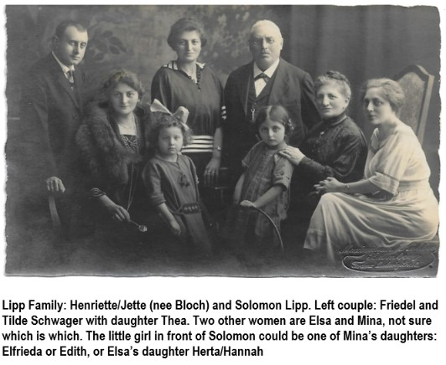

Lipp Family c. 1921. The couple on the left appears to be Siegfried and Tilda Schwager. Mina is standing next to Solomon. Elsa is seated next to Henrietta. The two little girls seem similar in age and therefore would be Edit and Thea. Identities need verification.

**Heinrich Bloch**

(September 10, 1865 – 1924)

Married **Fanny Bruell** (October 12, 1874 - ?) Had one daughter:

**Martha Bloch** (March 18, 1904 – August 2, 1994) married Siegfried (Freidel) Hauschild (May 4, 1894 -

1958). Immigrated to Kenya, and in 1960s immigrated to Australia. They had a daughter and son:

**Alice Therese Hauschild** (March 9, 1926 – August 26, 1986) married Alexander Friedrich Hermann

(March 28, 1918 – December 8, 1994)

**Henry Hauschild** (c. 1932 – September 3, 2021) married June Hendry

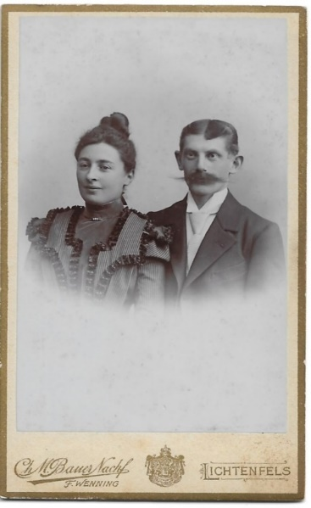 Fanny and Heinrich 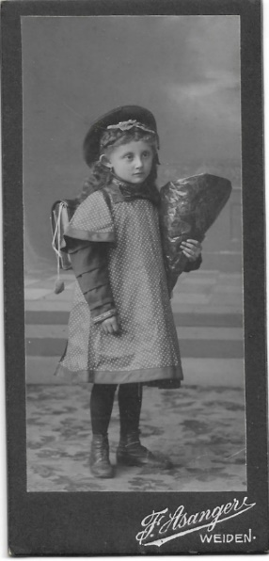 Martha

**The Hauschild story of immigration as recounted by my mother, Ursula Heiman Buckman: Fanny or Martha met and cared for the mother of Henry Morgenthau when she took ill while she was visiting Germany. Morgenthau was the US Secretary of the Treasury during the Roosevelt administration. With the rise of the Nazis, Martha and Siegfried Hauschild appealed to the Morgenthau’s for help in getting visas out of Germany. They were given documents so they could immigrate to Kenya, where they settled and ran a plantation. The Mau-Mau rebellion years made life very difficult; as well, Siegfried had died suddenly. Martha and her children once again uprooted and with their British citizenship were able to resettle in Australia where they remained the rest of their lives.**

**Anton** **Bloch**

(December 19, 1866 – May 17, 1943 Theresienstadt)

Anton immigrated to the US c. 1885, and married **Bertha Bomeisler** (January 5, 1867 – 1920) in 1888, in Philadelphia. He moved his family back to Germany prior to WWI.

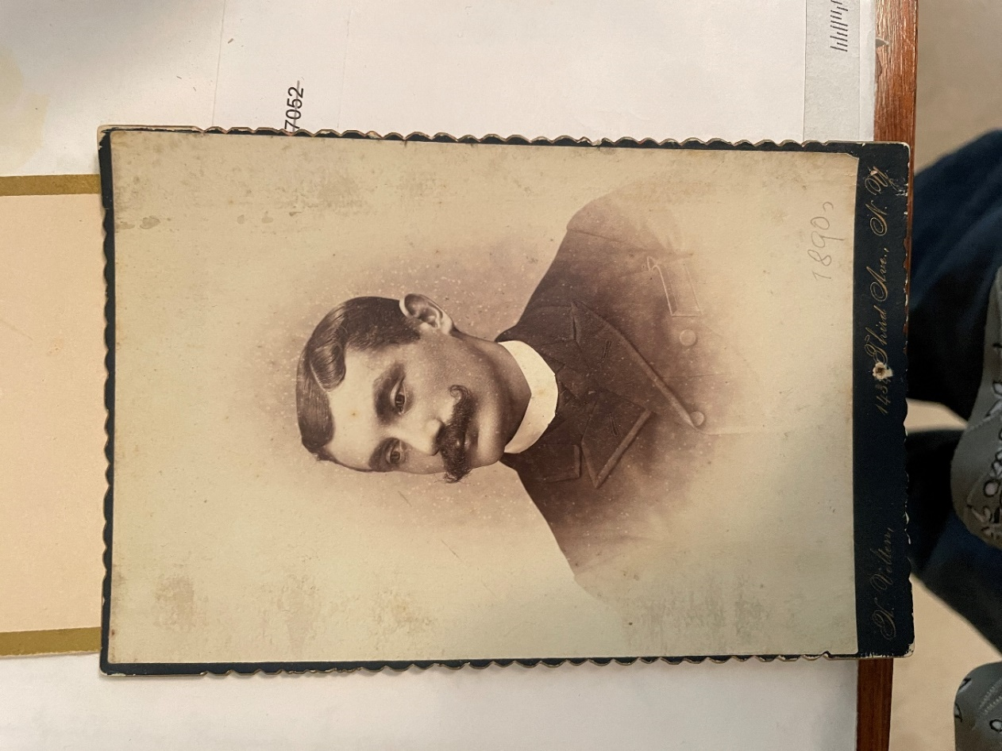

This photo was taken while Anton lived in New York City.

Anton and Bertha had two children:

**Adolf Bloch** (February 2, 1889 Philadelphia - December 3, 1938).

Unmarried, was an advocate/attorney, injured in WWI.

**Minnie Bloch** (April 15, 1891 New York City - 1937) married Jan 11, 1922, Theodor Oppenheimer

(January 11, 1878 - February 21, 1929). They had two sons:

**Bernd Oppenheimer** (March 14, 1923 - 1945 Auschwitz, after Russian offensive)

**Bruno (Baruch) Oppenheimer** (May 24, 1925 - May 13, 2000). Married Betty (Batya) Cohen

(October 6, 1921 - January 23, 2006) Immigrated to Israel.

**Joseph Bloch**

(September 24, 1868 – September 9, 1945)

Married **Louise Silberstein** (November 20, 1878 – September 30, 1976). Immigrated to London. They had two children: Alfred and Meta.

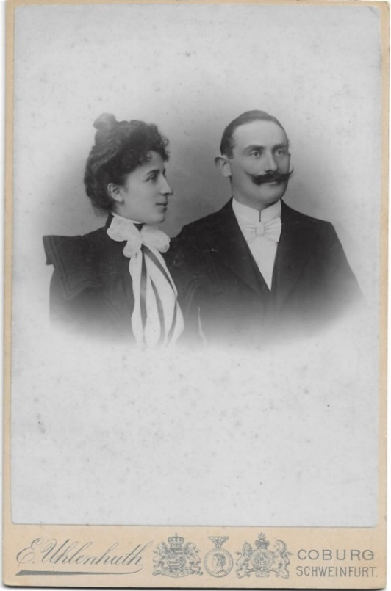 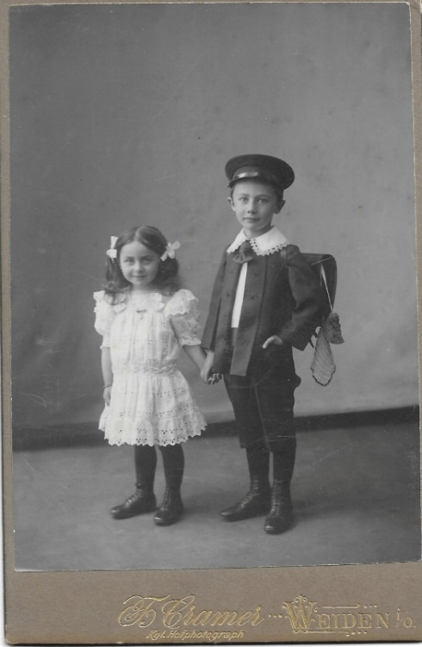

Louise and Josef Meta and Alfred

**Alfred Bloch** (August 1, 1904 - May 11, 1979 London), never married, Louise lived with him.

**Meta Bloch** (November 19, 1906 - February 13, 1990) married Alfred Bayer (June 23, 1899 - June 6,

1972). They immigrated to Sydney, Australia. They had one daughter:

**Marianne Bayer** (August 16, 1930 - August 4, 2003) married Jack Krygier

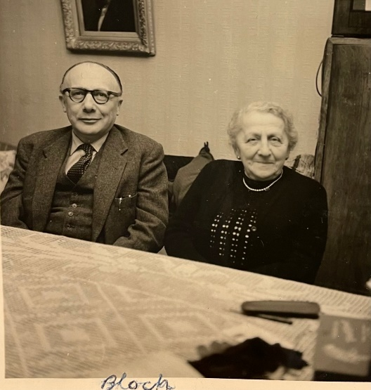 Alfred and his mother Louise in London, 1961

**Arnold** **Bloch**

(February 24, 1871 - March 17, 1943)

unmarried

**Sophie Bloch**

(April 15, 1872 – November 2, 1943 Theresienstadt)

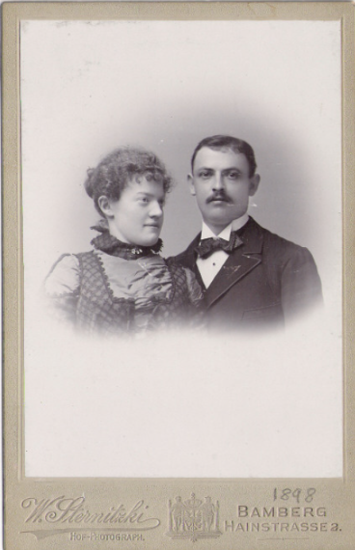

Married on June 28, 1898, **Julius Gustav Jonas** (August 14, 1868 – September 26, 1938). They had two daughters:

**Minnie** **Jonas** (April 3, 1899 – September 12, 1990) married Herman Heiman (April 14, 1898 –

Feb 23, 1977). They had a son and daughter:

**Udo Gunther Heiman** (March 1, 1924), married Lore Blake (December 11, 1926 - 2004)

**Ursula Renate Heiman** (April 18, 1926 – November 2, 2019) married Erwin Buckman (December 21,

1911 – October 19, 1996)

**Paula Jonas** (January 13, 1907, lived three days)

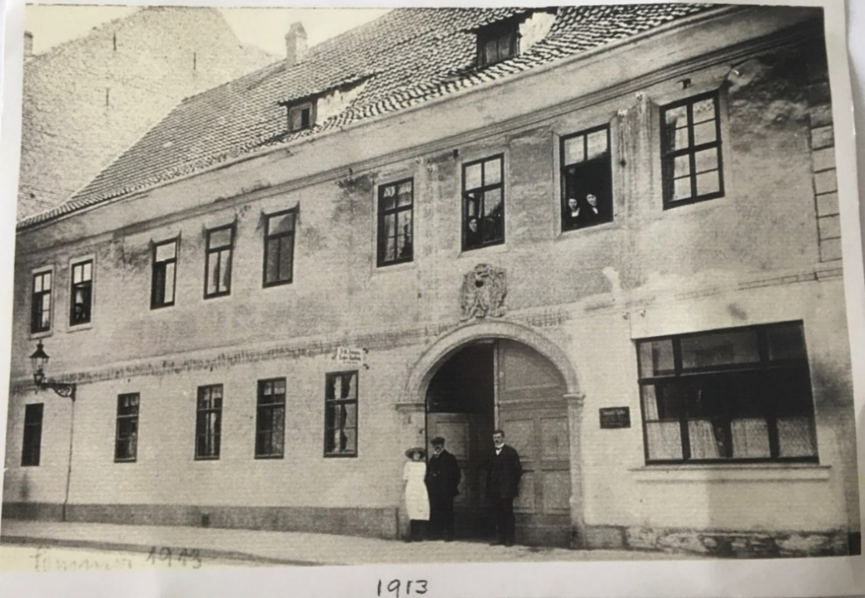

Sophie and Julius lived at Ritterstrasse 7, Arnstadt/Thüringen. The house was built in 1751 and was part of a palace complex. This photo is from 1912/1913 and shows Julius with daughter Minnie standing to the left.

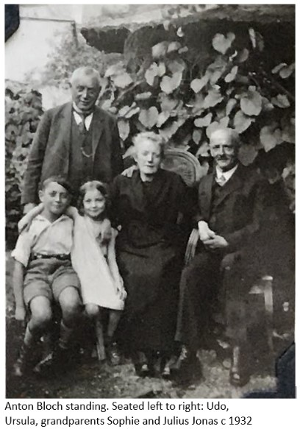

**This birthday poem was written by Sophie to her daughter Minnie after Minnie and family immigrated to America in 1939. Sophie, suffering from a broken hip and without a visa, had to remain behind. Despite threats from the Nazis, Franzi Gerner (who was not Jewish, worked for the Heimanns but came to be a sister to Minnie) went as often as she could to care for Sophie. Sophie and Anton were rounded up by the Nazis along with all the remaining Jews in Anstadt and eventually sent to Theresienstadt where they perished.**

To Commemorate My Dear Minnie on April 3, 1940 as a Little One

The way between us is so huge

But the closer we are connected.

Our thoughts reach easily

Yourself in just a few seconds.

Not weather, not storm, nor sea brewed

Can block their way

They don’t fly cross-wise, just cross-wise,

They know where they belong.

It goes from heart to heart in one go

In the loving feeling.

Only the poet and singer alone can do it

To bind your rhyme in words.

But no, they are still not enough,

To reproduce them in their size,

Because mother's love for her child,

It only happens once in a lifetime.

Anchored in the heart

You keep safe for all time,

Nothing in the world can lose your place

The mother’s love lasts forever.

**Attempts were made to get a visa for Sophie throughout the war. Here is one letter sent in 1945 to the Hebrew Sheltering and Immigrant Aid Society.**



**The application was approved, but Sophie had already perished.**